# Game Design Document

**Pitch**: TODO

**Name**: TODO

Alternative Names:

Brief Description: A simple runner using a tile map for level design. The player runs automatically and can jump to gather coins/boosts and has to avoid the obstacles and enemies.

**Purpose**

Why is your game being made? What do you hope to achieve?

The game is meant for me to grow my game development skills. I hope to get some feedback on some aspects of the game and become a better developer.

## Pre definitions

**Target player aspects**

* Age (minimum): 6+
* Culutre (Religion, Beliefs, Rituals, Habits):
* Gender: Not specific
* Region (Country, Contintent, City): Europe
* Income: F2P
* Familiarity (Casual, Hardcore): Casual

**Player Segment**

* Killers (Want to prove they are better by pking; Enjoy PvM; Like to mob other players): No
* Achievers (Want to become the best; Strive for best scores; Complete Achievements): Yes, achievements included for the stores
* Socializers (Interact with others; chat; invite friends; trade; help): No
* Adventurers (Like to explore; Find easter eggs and hidden items; Like to go into detail with story and background info): No

**Number of players**

* Single player: yes
* Multiplayer (2, 4 etc): no
* Both (1-4): no

**Platforms**

* PC: maybe steam
* Console (Xbox, Ps, Switch): no
* Mobile (iOs, Android): yes
* VR/AR: no

**Planning**

* Duration: 1-2 min a level, 10 levels in total
* Project Requirement: Assets for art, audio
* Realistic features: Achievements, Improve jump and run
* Realistic Time Limit for project to end: 2-3 Months
* Realistic goals

**Genre**

Mixed: Runner + platformer

**Mechanics**

* Main mechanic (must be amazing, must have basics and extra):
* Adapted mechanic (modifying existing mechanics)
* Mixed mechanics (mix 2 mechanics – run + shoot -> shoot while running)
* Meaningful mechanic (story related – eg. Spider man has some powers due to spider..)
* Tutorials always introduce mechanics!

|  |  |
| --- | --- |
| ***Mechanic*** | ***Mechanic explanation + features*** |
| Levels | Different level maps with difficulty |
| Run mechanic | Player constantly moves to the right – beware of collisions |
| Jump mechanic | Player can jump to avoid obstacles and gather coins or items |
| Upgrade | Spend the coins for improved jump; upgrade defense |

**Story**

* Start: Fantasy world
* Problem: Get to the finish goal
* Mission: Reach Level score
* End: Run to the end

**Gameplay**

Short description of core gameplay

Describe the specifics of the game play. Describe this from the perspective of a potential player, as a “user scenario”. Describe what the player sees when they start the game. Don’t spend too much time describing initial option menus, but concentrate on describing the main game play screens. Go on to describe the significant game mechanics, and play techniques through to both a win and lose situation. Describe the target platform and main user input controls (mouse, keyboard, arrow keys, game pad, KINEKT, tilt, touch etc.). If there are multiple levels, or the game gets harder as the player continues, describe the change from one level to another, and how the game gets harder. You may draw comparison to existing games, films, books, or other artists’ work to help describe your game.

**Goals**

* Main goal: Reach last level
* Secondary Goal: Level up and achieve highscore
* Side Goal: Have best jump ability
* Personal Goal for users (e.g. Improve my prev score, kill all monsters etc.)
* Winning and Losing Conditions: Lose when you collide with obstacle

**Interaction**

* Controller: Only leftclick / finger tap is used
* Actions
* Mappings

**Obstacles and Objects**

* Enemies: Monsters, Obstacles
* Skill Barriers: Low
* Levels: 10
* Objects: Coins

**Extras**

* Objects & Items
* Economy

Object functionalities:

***Item class # 1:*** *“General description and definition of items within category”*

*General feature #1*

*General feature #2*

*General feature #3*

*……………………………..*

*Subcategories: ……………………………………*

***Class #1 Subcategory #1:*** *“General description and definition of items within category”*

***Specific item list***

|  |  |  |  |  |  |
| --- | --- | --- | --- | --- | --- |
| ***Item name*** | ***Item index*** | ***Item description*** | ***Item Acquisition*** | ***Item specific value #1*** | ***Item specific value #2*** |
| *…………………………..*  *Name of item within video game* | *#.....*  *Index number often used within game programing to reference specific item* |  |  |  |  |
|  |  |  |  |  |  |

Economy:

*“General outline of the currency/economy within the video game”*

***Currency Purpose:***

*Outlined general purpose of the currency within the game.*

*Example: Stimulate play time through desires for customization*

***Currency Acquisition:***

*Method of currency acquisition*

*Currency yield, time to acquire, balancing mechanics, etc.*

***Currency Representation:***

*UI representation, textures, currency physical model*

|  |  |  |  |  |
| --- | --- | --- | --- | --- |
| ***Currency Use*** | ***Associated prices/exchange rates*** | ***Exchange effects (i.e., Acquisition of item, unlocking area, etc.)*** | ***Use Restrictions (i.e., Can only exchange currency for specific item once)*** | ***Use description + features*** |
| *Use #1* | *……………………………*  *……………………………*  *…………………………..* |  |  |  |
| *Use #2* | *……………………………*  *……………………………*  *…………………………..* |  |  |  |
| *Use #3* | *……………………………*  *……………………………*  *…………………………..* |  |  |  |
| *Use #4* | *……………………………*  *……………………………*  *…………………………..* |  |  |  |
| *………………………* |  |  |  |  |

**Rules**

* Rulebook
* Programming
* Good manners

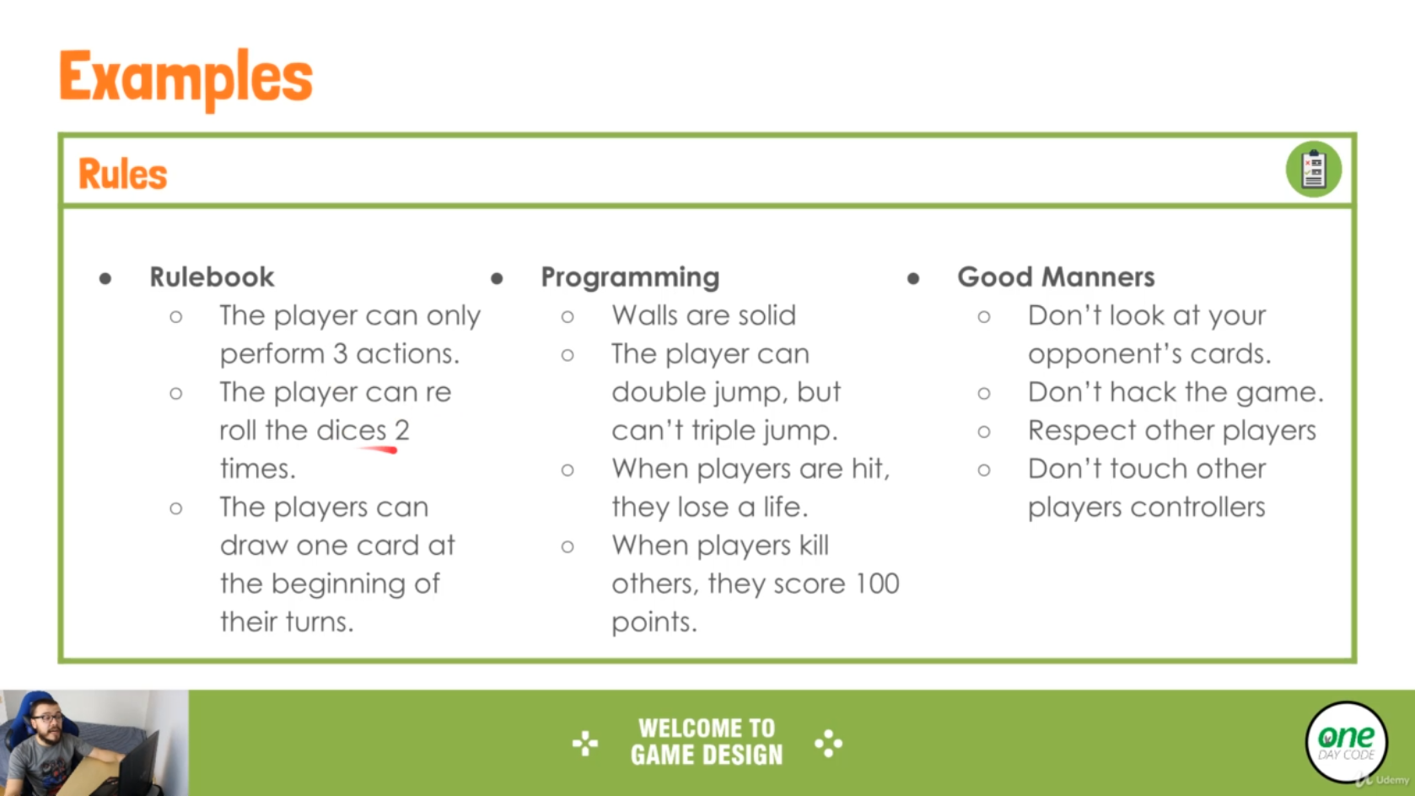

## In-Depth Documentation

Game flow summary: *Short summary of level structure/general game flow*

*“General description of level structure, referencing player objectives and transitions …………………………………………………………………………………………………………………………………………………………………………………………………………………………………………………………………………………………………………………………………………………………………………………………………………………………………………………………………………………………………………………………………………………………”*

|  |  |  |
| --- | --- | --- |
| ***Stage*** | ***Stage features (environment type, difficulty, unique enemies, etc.)*** | ***Number of levels*** |
| *Stage #1* | *Feature #1*  *Feature #2*  *Feature #3*  *…………………..* | *……………* |
| *Stage #2* | *Feature #1*  *Feature #2*  *Feature #3*  *…………………..* | *…………………* |
| *Stage #3* | *Feature #1*  *Feature #2*  *Feature #3*  *…………………..* | *…………………….* |

Game aesthetics: *Concept art, visuals useful, convey the games desired art direction.*

***Character Art:***

*“General outline of character aesthetics and features”*

*Feature #1*

*Feature #2*



***Environmental Art:***

*“General outline of world aesthetics and features”*

*Feature #1*

*Feature #2*



***Lighting:***

***Textures:***

***UI theme:***

Project Scope: *Estimations of project assets, level sizes, etc.*

***Game Objects:***

|  |  |  |  |
| --- | --- | --- | --- |
| ***Object class*** |  | ***Total number of Assets*** | ***Timeline estimates*** |
| *Character* | *Character 1*  *Character 2*  *Character 3* | ……………………………. | ……………………………… |
| *Environmental assets* | *Environmental Asset 1*  *Environmental Asset 2*  *Environmental Asset 3* | …………………………… | ……………………………….. |
| *Weapons* |  | ……………………….. | …………………………………. |
| *UI elements* |  | ………………………. | …………………………. |
| *………………………* | ……………………………………… | …………………………… | …………………………… |

***Scripting Systems:***

|  |  |  |
| --- | --- | --- |
| ***System*** | ***Required functionalities*** | ***Timeline estimates*** |
| *System 1* | *…………………………………………………………………..*  *………………………………………………………………..*  *……………………………………………………………..* | Length of implementation:  …………………………………….. |
| *System 2* | *…………………………………………………………………..*  *………………………………………………………………..*  *……………………………………………………………..* |  |
| *System 3* | *…………………………………………………………………..*  *………………………………………………………………..*  *……………………………………………………………..* |  |

***Dialogue:***

*Mission specific dialogue:*

|  |  |  |
| --- | --- | --- |
| ***Mission name/number*** | ***Lines of dialogue*** | ***Character list*** |
| *Mission 1* | *Number of lines: …………….* | *………………………*  *……………………*  *……………………*  *……………………*  *……………………* |
| *Mission 2* | *Number of lines: …………….* | *………………………*  *……………………*  *……………………*  *……………* |
| *Mission 3* | *Number of lines: …………….* | *………………………*  *……………………*  *……………………*  *……………* |

***Music + Sound effects:***

***Game Art:***

***Levels:***

Monetization strategy: *Overview of how the video game will be monetized.*

***Monetization strategy:*** *………………………*

***Elected strategy guidelines:***

*……………………………………………*

*………………………………………….*

*…………………………………………….*

*………………………………………….*

Game world description:

***Game map:***



***Location breakdown:***

|  |  |  |  |
| --- | --- | --- | --- |
| ***Location*** | ***Associated lore*** | ***Location features*** | ***Featured levels*** |
|  |  |  |  |
|  |  |  |  |
|  |  |  |  |

***Location:*** *……………………*

*Associated lore:*

*“…………………………………………………………………………………………………………………………………………..*

*………………………………………………………………………………………………………………………………………..*

*………………………………………………………………………………………………………………………………………..”*

*Location features:*

*Location feature #1*

*“………………………………………………………………………………………………………………………………………………………………………………………………………………………………………………………………………………………………………………………………………………………………………………………………………………………………………………………………………………..”*

*Location feature #2*

*“……………………………………………………………………………………………………………”*

*Featured levels:*

|  |  |
| --- | --- |
| ***Level name + number*** | ***Location level breakdown*** |
|  |  |
|  |  |

Level design ethos:

***Aesthetics:***

***Level architecture:***

***Flow:***

Character summaries:

***Main Characters:***

***Character:*** *……………………*

*“General character sketch outlining personality, role within game and several character quirks.”*

***Backstory:***

………………………………….

……………………………….

…………………………………..

***Character Aesthetics:***

***“……………………………………………………………………………………………………………………………………………………………………………………………………………………………………………………………………………………………………………………………………………………………………………………………………………………………………………………”***

***Character Attributes:***

***“……………………………………………………………………………………………………………………………………………………………………………………………………………………………………………………………………………………………………………………………………………………………………………………………………………………………………………………”***

***Character Role:***

***“……………………………………………………………………………………………………………………………………………………………………………………………………………………………………………………………………………………………………………………………………………………………………………………………………………………………………………………”***

***Minor Character List:***

|  |  |  |  |
| --- | --- | --- | --- |
| ***Character name*** | ***Encountered*** | ***Character description*** | ***Dialogue*** |
| *“Name of character”* | *Levels/stages the character is present within* | *Character aesthetics, personality, backstory, etc.*  *……………………………*  *…………………………..*  *………………………….* |  |
| ***Purpose:*** *“Characters purpose within the game, i.e., Giving player mission/item, brief lore/dialogue opportunity, background filler, etc.* | | | |
| *…………………………* | ***……………………………….***  ***……………………………..***  ***…………………………….*** | *…………………………………*  *……………………………..*  *……………………………..*  *………………………………*  *………………………..* |  |